Instruction: How to modify and submit this document:
- Make a copy: File -> Make a copy
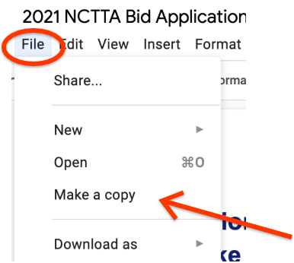
  - Give your new file a descriptive name
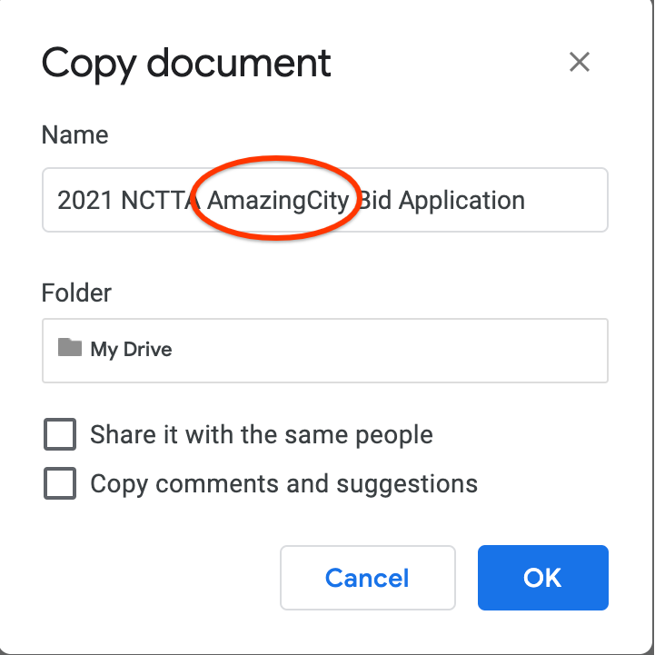
- Make your edits in the new file
- Share it with president@nctta.org & vicepresident@nctta.org
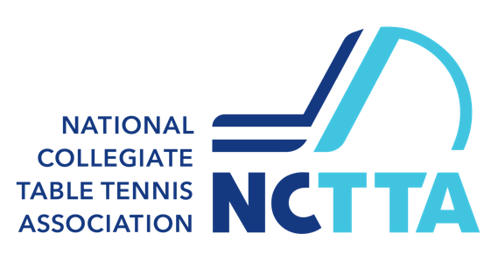
2021 College Table Tennis National Championships

Bid Application
Table tennis is the most popular sport in the world by participation. The College Table Tennis National Championships features the sport that everyone has at one point played and loved; played here at the highest level. The College Table Tennis National Championships is one of the premier table tennis events in North America, featuring 40 of the best college table tennis teams in the United States and Canada. The event features a myriad of different men and women; student athletes from diverse backgrounds, with Olympians and Olympic hopefuls among them.

The College Table Tennis Championships are your chance to bring a national sporting event to your community, drawing interest and attention to your city, and generating economic impact for local businesses. The Championships encompass five different singles, doubles, and team and events, held over 5 days each year, on a weekend in April.

About NCTTA:

The National Collegiate Table Tennis Association (NCTTA) is a non-profit organization established exclusively for organizing the sport of table tennis at the college level. As the national governing body for college table tennis in the United States and Canada, NCTTA organizes intercollegiate competition throughout North America. For more information visit: www.nctta.org.

Bid Information Snapshot:

Time of Year: Early April, preferably first two weekends (Easter weekend is not preferred)
Length of Event: 5 days, Wed. to Sunday (1 set-up day, 1 practice day, 3 days of competition)
Number of Teams: 40 teams; 4 to 8 players per team, plus coaches/chaperones
Number of Participants: 300
Number of Online Spectators: 2000 during competition, >50,000 views for playback within 6 months
Average Length of Stay: 3-4 nights per team
Room Nights: 300-400
Room Rate: Under $99.00/night preferred

Bid Deadline: January 31, 2020

Submit completed application via email to both president@nctta.org and vicepresident@nctta.org.

By completing this application, you, the bidder, agree that the information included in your bid is accurate to the best of your knowledge, and that you are willing to work closely with NCTTA putting forth the necessary amount of effort to make the Championships a successful event, including all facets of planning, preparation, and execution of the event.

Please provide the information requested in each section below.

Host Organization:

HO01 | Name of host organization
HO02 | Name of city/state
HO03 | Name of the primary person and four secondary persons responsible for the Championships planning. For each member of the organizing committee, list experience and credentials in running local, regional, and/or national events.
HO04 | Name of authorized signer of a host contract with NCTTA if your bid is selected.
HO05 | List any supporting organizations and their primary and secondary persons.
HO06 | List 3 other events your organization has hosted in the past.

Competition Venue:

The competition venue must be a gym, sport center, or other facility reserved by the host organization. Competition space must have wood floors, rubberized athletic flooring, or another flooring surface suitable for athletic competition. Bare cement or carpet will NOT be considered unless there is a plan in place to bring in wood or rubberized athletic flooring for the duration of the competition. The venue must be able to accommodate:

- A minimum of 18 competition courts 40’ x 20’ in size.
- Space for aisles and team benches at each court.
- A minimum of 12 practice courts 30’ x 15’ in size.

A typical venue would encompass 40,000 to 50,000 square feet of competition and practice space, plus additional space for spectators, officials, sponsor/vendor booths, competition control area, meeting rooms, etc. Eight basketball courts would be an example of the minimum requirement, but if desired square feet was reached (with less courts) we could still consider the bid.

In addition, fenestration or glare is a huge detriment to any Table Tennis tournament so all exterior windows need to be covered at the expense of the host.

We would require access to a facility for the following times:
Wednesday evening (Set up) 4pm to 10pm
Thursday (Set up) 8am to 9pm
Friday (Competition) 7:30am to 11pm
Saturday (Competition) 7:30am to 8pm
Sunday (Competition) 7:30am to 5pm
Sunday (Teardown) until 11pm
Monday (if needed) until noon

CV01 | Please attach electronically, four photos of the venue from different angles at the end of this document.
CV02 | What is the name and address of the Competition Facility?
CV03 | Please attach a venue floor plan/diagram indicating key areas and DIMENSIONS of the competition venue at the end of this document.
CV04 | Describe the flooring surface in the competition space.
CV05 | Describe the lighting (direct or indirect).
CV06 | What is the light intensity in the competition space (in lux or foot candles)?
CV07 | Are there any windows visible within vicinity of the competition space? If so, can the windows be covered to block natural light?
CV08 | What is the height of the ceiling over the competition space?
CV09 | Number of restrooms in vicinity of the playing area. Are the restrooms ADA-accessible?
CV10 | Is there space available for sponsor/vendor booths near the competition area? If so, how much?
CV11 | Are there locker rooms in the venue? If so, how many?
CV12 | Please describe the public address system/sound system in the venue?
CV13 | What kind of seating is available for spectators? Are there bleachers? (Bleachers are preferred) Moveable seating? How many spectators can be accommodated?
CV14 | Does the venue have a controlled entrance point for admission purposes?
CV15 | Is parking at the venue free? If not, what are the parking rates?
CV16 | Is there a concession stand available in the facility? Are there restaurants within walking distance of the facility? Can outside food be brought into facility?
CV17 | Are there extra rooms/meetings rooms available at the venue?
CV18 | Are there hospitality/lounges areas available?
CV19 | Is Internet access available in the venue? What is the upload and download bandwidth?
CV20 | Are janitorial services available throughout the duration of the Championships weekend?
CV21 | Does the facility/venue employ personnel that are CPR and First Aid certified that we can utilize during the event? If so, how much?
CV22 | Can the host organization secure the venue with contract?

Hotel:

One hotel should be designated as the host hotel. The host hotel needs to have enough rooms to accommodate all athletes, coaches, staff, and out of town volunteers in addition to being able to provide meeting rooms for coaches, officials, and space for team registration. NCTTA will sign a contract with the hotel that the host organization advises.

Please note that you are required to contact John Larsen and Shelly Huang of Helms Briscoe to get additional information on the specific hotel requirements. John can be reached at 507-288-6566 or jlarsen@helmsbriscoe.com and Shelly can be reached at 361-425-8711 or shuang@helmsbriscoe.com . They will send you a document detailing the NCTTA’s hotel requirements. All hotel proposals will need to be sent through the Helms Briscoe Cvent system for John/Shelly’s and the NCTTA’s review. John and Shelly will also be your point of contact regarding any hotel questions and discussions. Please note that the NCTTA is aware of the 10% placement fee that the hotel pays to Helms Briscoe.

Please attach any additional information at the end of this document.

Banquet/Meeting Space:

A Championships banquet is expected for the athletes, coaches, officials, volunteers and any designated dignitaries. The banquet is typically held Saturday evening of the Championships weekend. Seating capacity should be between 300-350 people. Alcohol cannot be served at the banquet.

There is a need for space in the lobby of a hotel or a dedicated room to conduct tournament registration on the afternoon prior to the start of the event. A board meeting room is needed for the last night of the event.

Please note that you are required to contact John Larsen and Shelly Huang of Helms Briscoe to get additional information on specific banquet requirements. Their contact information is listed above and will send you a document detailing the NCTTA’s championship banquet requirements. John and Shelly will also be your point of contact regarding any banquet/meeting space questions and discussions.

Transportation:

Please provide transportation information for the surrounding area (airports, highways, train stations, public transit, etc.). Transportation is expected between the airport(s) and host hotel, and between the host hotel and the competition venue. NCTTA will look favorably towards a bid where the hotel is close to the competition venue.

Please provide a plan for assisting with transportation:
T01 | Between airport(s) and hotel (on travel days)
T02 | Between hotel and competition venue (on competition days)
T03 | Between hotel and banquet on Saturday (if needed)
Transportation (as described in your plan above) will be:
T04 | Complimentary (provided at no charge to the event budget)
T05 | Event-related expense (charged to the event budget)
T06 | Participant-related expense (expense charged to participating teams)
T07 | Combination of both T05 and T06
T08 | What is the distance (in distance and travel time) from area airports/train stations to the hotel?
T09 | How far (in distance and travel time) is the hotel from the competition venue?
T10 | How many different airlines offer regular flights to area airport(s)?

Media Coverage & Marketing/Promotions:

NCTTA depends on the host organization to promote and publicize the event and/or have the ability to create media coverage for the event. We hope the organization has experience promoting these types of events and getting good publicity for it. Please answer the questions below.

MC01 | Describe your plan for media coverage for the Championships, including plans for local, regional, national coverage on radio, television, in newspapers, on the Internet or through other media outlets.
MC02 | How many people do you expect to reach through TV and other media outlets identified above?
MC03 | Would the host organization be able to designate a local media coordinator?
MC04 | How do you plan to attract local spectators, including those from outside of the sport?
MC05 | The live spectator rights for the Championships are available for bid. Are you interested in purchasing these rights?

Championships Program:

Event programs are an important part of the Championships. Players and spectators will collect them and use them as a guide to the different activities at the Championships. Each participant will typically receive a complimentary program as a souvenir. Ad space is available for potential sponsors, and is a way to generate revenue along with sales of programs to spectators. We would expect for local organizing committee to help sell ad space to local businesses to further attract to the event and for the event.

CP01 | Can the host organization provide assistance in designing the Championships program? A) provide them free of charge or B) provide them at a fee or C) Suggest a contractor or D) Cannot assist
CP02 | Can the host organization provide assistance in printing the Championships program? A) provide them free of charge or B) provide them at a fee or C) Suggest a contractor or D) Cannot assist
CP03 | If C) was selected above, please list local businesses or representatives.

Volunteer Plan:

Volunteer support is critical to the success of the Championships. We require your bid to name a Volunteer coordinator from the local area (preferred from the local Table Tennis club) to be an integral part of this process. In particular, as many as 75 volunteers are employed in the following areas: registration, hospitality, venue set up and take down, field of play coordinators, practice area coordinators, umpires, scorekeepers, control desk runners, and production. This Volunteer coordinator will work with our Championship Tournament director to fill spots needed for the Championships.

Volunteer Requirements
Date/Time | # of volunteers required | Task
Wednesday 7-11pm | 10 | Setup Tables/Barriers
Thursday 9am to noon | 25 | Set up: Flooring, Table placement, Video production
Thursday 1pm to 5pm | 15 | Set Up (continued): Flooring, Table Placement, etc.
Friday 8:30am to 1pm | 15 | Scorekeepers/Umpires
Friday 12:30pm to 5pm | 15 | Scorekeepers/Umpires
Friday 4:30pm to 9pm | 15 | Scorekeepers/Umpires
Saturday 8am to 12:30pm | 15 | Scorekeepers/Umpires
Saturday 12pm to 4pm | 15 | Scorekeepers/Umpires
Sunday 8am to 12:30pm | 15 | Scorekeepers/Umpires
Sunday 12pm to 4pm | 15 | Scorekeepers/Umpires
Sunday 2pm to 9pm | 25 | Tear down: putting up tables, barriers, pulling up flooring and assistance with video production

The host, in conjunction with local table tennis clubs, is expected to provide 15 full-time volunteer umpires. Umpires are typically table tennis players who have had several hours of study, training, practice, and certification prior to the competition. NCTTA can assist in training umpires if necessary.

VP01 | What is your plan for recruiting local volunteers for the event?
VP02 | Does the host organization have staff or volunteers that are able to assist the NCTTA tournament officials during the event?
VP03 | What support can be expected from any local table tennis club(s)?
- In the event host organization does not provide ample enough volunteers to execute a successful event beginning to end, and NCTTA is forced to hire external (temp labor), this cost will be taken on by the host organization.
Please do not hesitate to attach any other pages containing helpful information with regard to volunteer support at the end of this document.

Site Visit:

NCTTA Representatives conduct a site visit several months prior to the event to tour and inspect the host hotel and facilities. This also serves as an important opportunity to meet with local officials and advance planning for the Championships.

SV01 | Can the host organization fund a site visit for up two NCTTA representatives? Funding is specifically accommodations, travel and accommodations.
SV02 | What is the best time of year to conduct a site visit? Site visit is typically done sometime between August and December.
SV03 | NCTTA is requesting that the host organization provide storage facility with temp control for the equipment/flooring, up to a year (12 months) leading up to the championships. Space requirement is 10 by 15

Please contact John Larsen with Helms Briscoe at jlarsen@helmsbriscoe.com for more information on which NCTTA representatives will attend and to determine a mutually agreeable date to visit your city.

Sponsorships:

NCTTA understands that without sponsorship opportunities that the Championships would not be financially viable, but also in realizing this venture is a product owned by NCTTA and managed by ISET, NCTTA reserves the right to seek out, secure and retain any revenue from sponsors of these Championships.

Varying sponsorship levels can be pursued by the host organization. All sponsor agreements for the event must be coordinated and approved by NCTTA.

S01 | Can the host organization assist with procurement of sponsors for this event?
S02 | Name any entities you plan to approach for sponsorships?
S03 | Are there any sponsorships already in place? Venue? Transportation? Banquet? Etc.?

Budget:

Please include a budget with anticipated expenses. Providing an accurate budget is essential to ensure a fair bidding process, and bidders are expected to verify the accuracy of their budget estimates by contacting relevant parties as needed. Failure to provide reasonable estimates may result in bid award cancellation, and/or additional sanctions. The following items are typically included in the budget, even though this is not an exhaustive list. Please indicate if NCTTA is to pay or some other organization.

 | ITEM | AMOUNT | WHO PAYS ALL OF IT | CVB WILL SUBSIDIZE
BU01 | Venue Rental
BU02 | Banquet
BU03 | Site Visit: (hotel stays and travel)
BU04 | Athlete and Staff Lunches
BU05 | Insurance
BU06 | Photography
BU07 | Staff and Tournament Shirts
BU08 | Flooring Storage Facility rental
BU09 | Supplies (Office Products)
BU10 | Printing Costs: event programs, signs, posters, marketing materials
BU11 | Transportation
BU12 | Audio Visual Equipment
BU13 | Tables/Chairs/Bleachers

Contract with NCTTA

NCTTA feels the championships’ success is dependent on a partnership between the host organization and NCTTA itself. We like to sign a contract stipulating each party’s responsibilities, both logistical and financial.

We are a full volunteer organization and want a host CVB/Sports Commission/local host to be involved with the set up and preparation of the event. This involvement could include monthly or bi monthly conference calls on a Sunday or week day night.

C01 | Can host organization sign into a contract of this nature?
C02 | Can host organization enter into a contract stipulating responsibilities and or where financial obligations are split or a limit is set to how much one organization can earn or lose in said championships?
C03 | Does host organization have a logistics manager that can attend monthly (outside of regular work hours) calls prior to the championships?

For More Information (questions or to submit) contact:
Willy Leparulo, NCTTA President, president@nctta.org
Joseph Wells, NCTTA Vice President, vicepresident@nctta.org

